Beneficiaries: 1200 children

Books received: 180

Coordinator: Sheila Abia-Okon

Author: Sameera Nuru

Sponsor: Bhamuson Foundation Charity

Introduction

Bhamuson Foundation is a UK registered Charity, that helps to support children attending underprivileged primary schools in Nigeria. Our aim is to increase their standard of education, by providing the children with books, renovating their classrooms and creating a conducive learning environment for the children.
Bhamuson Charity goes through the process of identifying schools that need assistance, raising the relevant funds and executing the projects by using direct labour, sourced from the local community. We supervise the projects from start to completion. In addition, we provide educational equipment to support and enhance teaching in these schools. The goal is to provide a safe, clean and stimulating environment for learning which would put a smile on the faces of the children.
Recently, Bhamuson foundation received over one hundred and sixty books from Book2Africa, which it donated to the two schools currently in partnership with the charity; Adeta Primary School and African Central Church School.
The books donated included Literary skills, Mathematics, English grammar, Nursery rhymes, exercise books and dictionaries for nursery classes through to primary six.
The aim is to start a library in both schools, to encourage the kids to read more books and provide other educational supplies to enhance teaching methods in these schools.

Logistics
The books were individually hand picked from Book2africa at the warehouse in Canterbury. Many thanks to all the staff at Canterbury for their courteous and extremely helpful gesture in allowing Bhamuson to select the books.

Impact

On Friday 24th of November 2017 approximately eighty books were donated to Adeta Primary School in Kwara State of Nigeria, during the opening ceremony of a block of three classrooms which were renovated by the charity. These books will benefit over 600 hundred children in the school, providing the much-needed useful books.
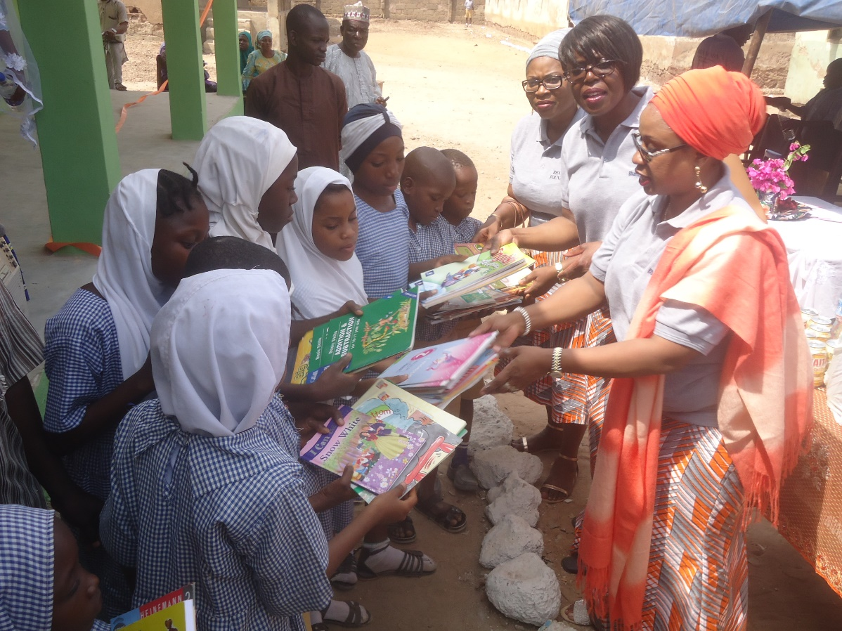
Book donation at the Adeta Primary School, Kwara State, Nigeria
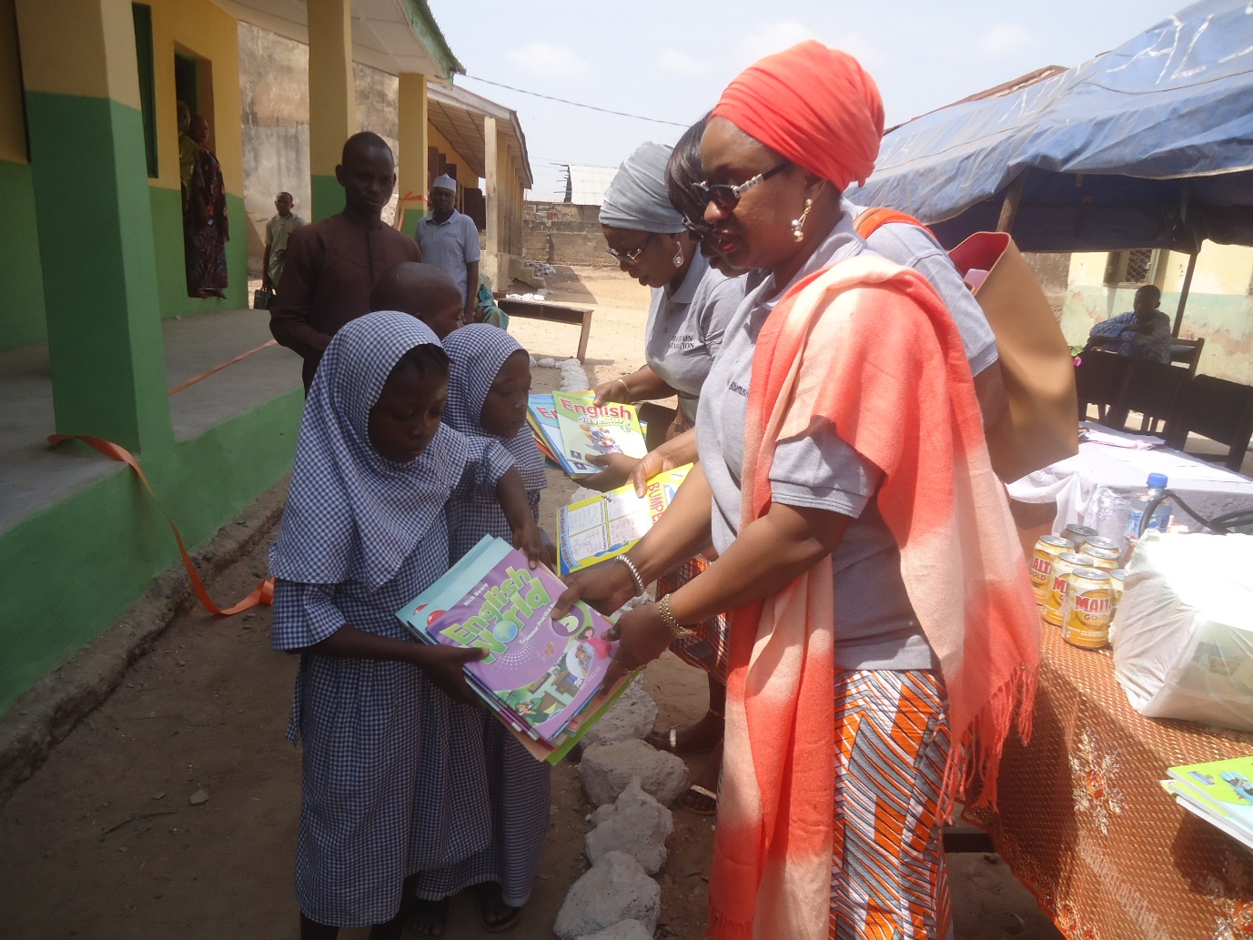
Book donation at the Adeta Primary School, Kwara State, Nigeria
This is the first of many as the foundation hopes to donate more books in the future, which will lead to the formation of new libraries for the kids and a follow up of constant engagements like reading and improving their writing skills, and fulfilling our goal of helping to critically develop young minds to become innovative and creative individuals, through an improved reading culture.
On Monday 27th of November 2017, approximately eighty books were donated to ACCS Primary School in Ogun State of Nigeria, during the opening ceremony of a recently renovated classroom by the charity. These books will also benefit over 600 children in the school, providing the much-needed useful books.
In the long run, we hope that the books would give the children the opportunity to get a higher quality education that would enable them to compete locally as well as globally with their peers. The new books would also encourage a positive reading attitude among the children as they bring fresh literary content into the school environment. The books were also donated in the form of prizes at the prize giving day of ACCS (African Church Central School Ota, Ogun State, Nigeria). By using the books as prizes for important school events like prize giving day, the books have created an incentive for the children to perform well academically as they would like to be recognized and receive brand new books they have never had the opportunity to own.
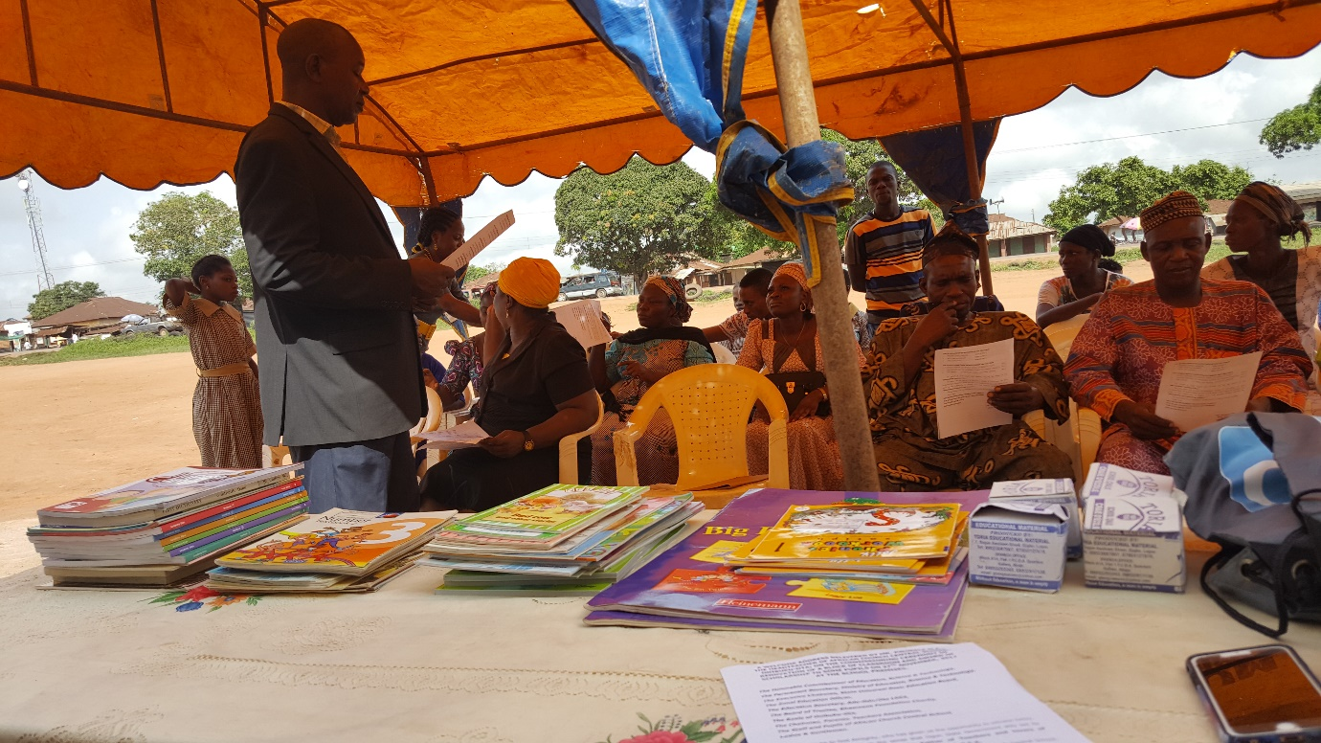
Book donation at the African Church Central School, Ogun State, Nigeria

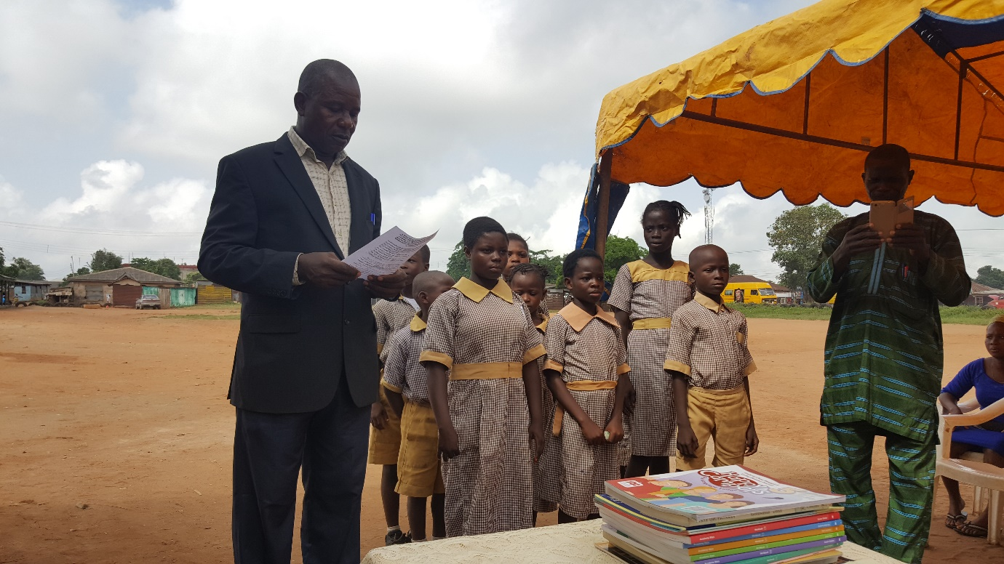
Children awarded some books as part of the prize giving
African Church Central School, Ogun State, Nigeria

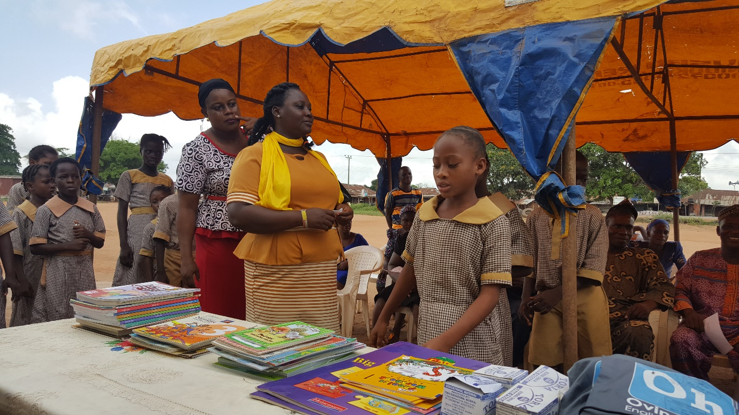
Book donation at the African Church Central School, Ogun State, Nigeria

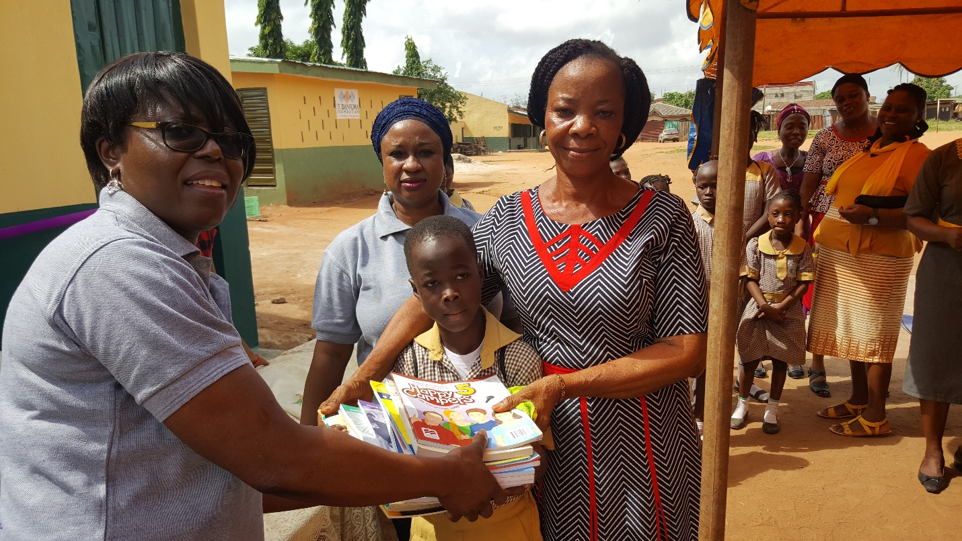
Book donation at the African Church Central School, Ogun State, Nigeria
Author by
Sameera Nuru

